**Facade Pattern**

Facade is a structural design pattern that provides a simplified interface to a library, a framework, or any other complex set of classes.

Facade her hansi bir cliente coxlu big data arasinda ona lazim olan seyi daha asanliqla goturemyi teklif eden patterndir.

Mes. konkret basliqlar ile

**Beahvarioal Pattern**

Obyektlerin arasida olan elaqler, ohdelikler, alqortimleri gosteren pattern qrupudur.

**Chain Of Responsibiity Pattern**

Chain of Responsibility is a behavioral design pattern that lets you pass requests along a chain of handlers. Upon receiving a request, each handler decides either to process the request or to pass it to the next handler in the chain.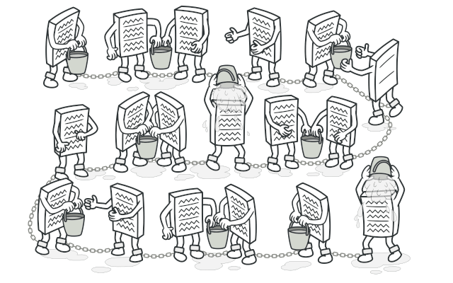

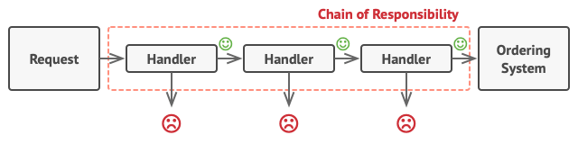

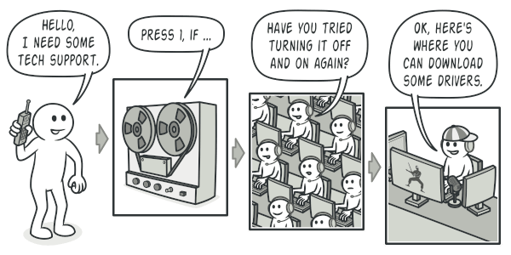

Responsibilityler next next ile baglanib, novbelesirler.